EX:4 | EXPLORATORY DATA ANALYSIS (EDA) – DATA INSPECTION, FILTERING, STATISTICAL ANALYSIS AND CORRELATION
DATE:

AIM:

To perform data inspection, filtering, grouping, aggregation, descriptive statistical analysis, and correlation analysis using Pandas and visualize the results using Matplotlib..

ALGORITHM:
- Start.
- Import the required libraries (Pandas and Matplotlib).
- Read the student dataset from the CSV file into a DataFrame.
- Display the dataset, its data types, and dimensions to understand its structure.
- Filter the required records and sort the dataset based on Internal Marks.
- Calculate statistical measures such as Mean, Median, Mode, Standard Deviation, and generate the statistical summary.
- Find the correlation between Internal Marks and External Marks.
- Visualize the data using a Bar Chart, Box Plot, and Scatter Plot.
- Display all the outputs and graphs.
- Stop.
PROGRAM:

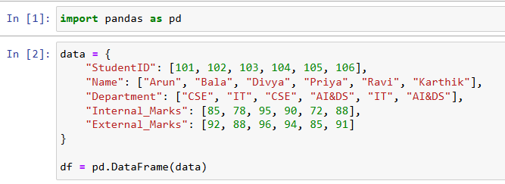
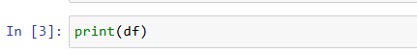
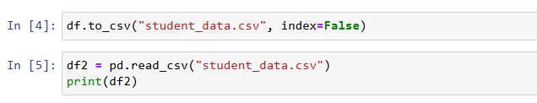

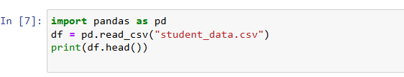

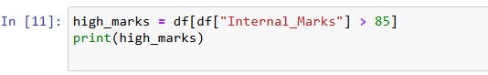

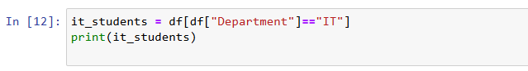

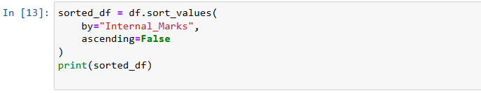

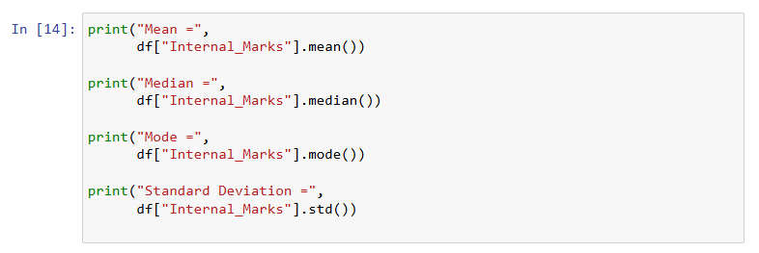

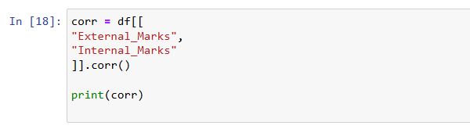

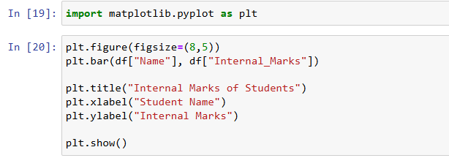

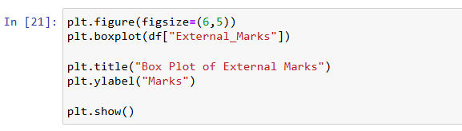
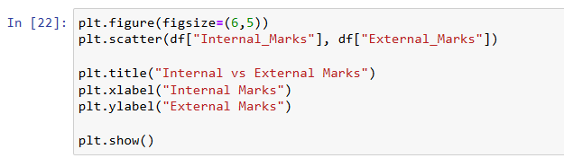

OUTPUT:
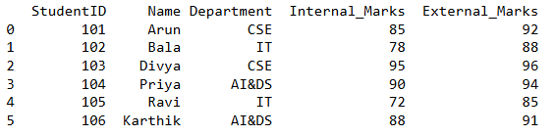
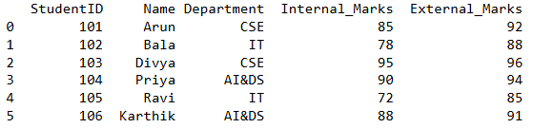
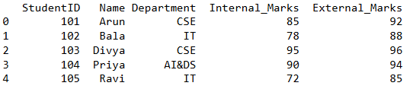
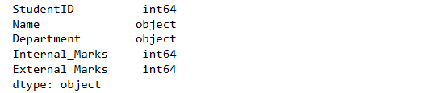
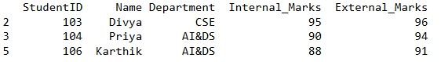
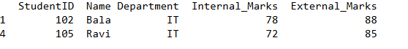
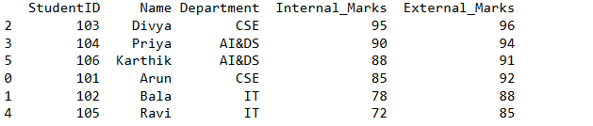
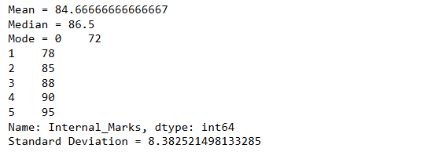
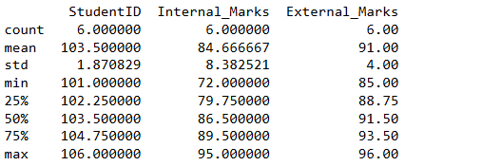
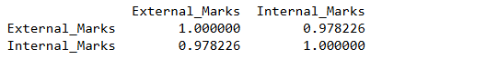
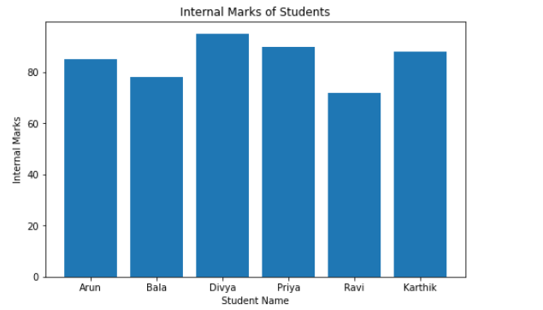

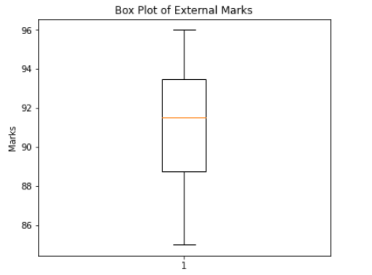
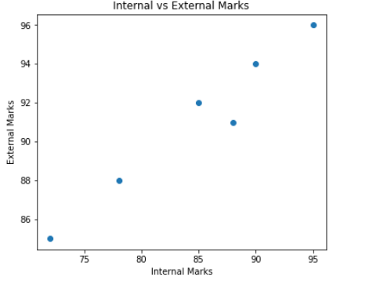

RESULT:

Thus, data inspection, filtering, sorting, descriptive statistical analysis, grouping, aggregation, and correlation analysis were successfully performed using Pandas. The analytical results were visualized and interpreted successfully.

